M.PAVITHRAN
192411014
INTERNET PROGRAMING-CSA4308

LAB PROGRAMS

1. A local library needs a website to streamline operations and enhance user
experience. The site will include a catalog for searching and viewing books, user
accounts for borrowing and managing books, and an admin dashboard for
managing inventory and user data. Essential features include a search function,
book details page, user login system, and contact form, The system helps both
students and library managers to keep constant track of all the books available in
the library. It allows both the admin and the student to search for the desired book.
It becomes necessary for colleges to keep a continuous check on the books issued
and returned and even calculate fines.
Librarian Admin:
• Login
• Add Book
• Update/Delete Book
• Issue Book for student
• Return Book Status
• Make Fine
• Update material ( year, semester wise )
• View material
User
• Login
• Register
• Search Book
• My Borrow History Book
o Issue Date, Exp Date
• Check Fine
• Search material ( year, semester wise )
• Download material
• My profile
<!DOCTYPE html>
<html lang="en">
<head>
<meta charset="UTF-8">
<meta name="viewport" content="width=device-width, initial-scale=1.0">
<title>Library Management System</title>

<style>
*{
margin:0;
padding:0;
box-sizing:border-box;
font-family:Arial, sans-serif;
}

body{
background:#f2f2f2;
}

header{
background:#2c3e50;
color:white;
padding:20px;
text-align:center;
}

nav{
background:#34495e;
padding:15px;
text-align:center;
}

nav a{
color:white;
text-decoration:none;
margin:20px;
font-size:18px;
}

nav a:hover{
color:yellow;
}

.hero{
padding:50px;
text-align:center;
background:white;
}

.hero h1{
color:#2c3e50;
}

.hero p{
margin-top:15px;
font-size:18px;
}

.container{
display:flex;
justify-content:space-around;
margin:40px;
}

.card{
background:white;
padding:20px;
width:250px;
border-radius:10px;
box-shadow:0 0 10px gray;
text-align:center;
}

.card h3{
margin-bottom:15px;
}

.card button{
background:#2c3e50;
color:white;
padding:10px 20px;
border:none;
cursor:pointer;
margin-top:15px;
}

.card button:hover{
background:#27ae60;
}

footer{
background:#2c3e50;
color:white;
text-align:center;
padding:20px;
margin-top:40px;
}
</style>

</head>
<body>

<header>
<h1>Library Management System</h1>
<p>Online Book Management Portal</p>
</header>

<nav>
<a href="#">Home</a>
<a href="#">Books</a>
<a href="#">Login</a>
<a href="#">Register</a>
<a href="#">Contact</a>
</nav>

<section class="hero">
<h1>Welcome to Library</h1>

<p>
Search books, borrow books, check fines and download study materials.
</p>

</section>

<div class="container">

<div class="card">
<h3>Search Books</h3>
<p>Find books by title, author or category.</p>
<button>Search</button>
</div>

<div class="card">
<h3>Student Login</h3>
<p>View borrowed books and download materials.</p>
<button>Login</button>
</div>

<div class="card">
<h3>Admin Login</h3>
<p>Manage books, students and fines.</p>
<button>Admin</button>
</div>

</div>

<footer>

<p>© 2026 Library Management System</p>

</footer>

</body>
</html>
OUT PUT:

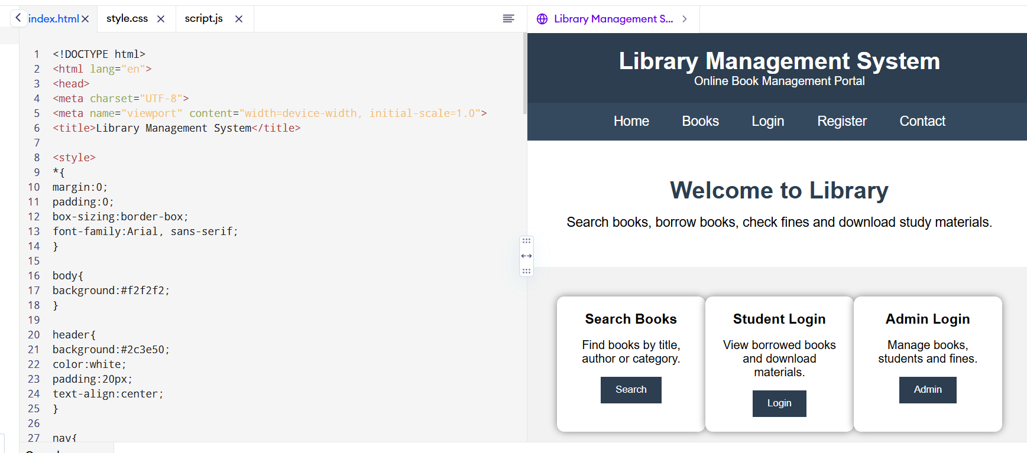

2. The online hotel room booking website allows users to search for hotels based on destination,
dates, and number of guests, offering detailed listings with room options, prices, amenities, and
reviews. Users can create accounts, log in, and manage their bookings through a user-friendly
dashboard. The booking process includes checking room availability, filling out a booking form,
and completing secure payments via an integrated payment gateway. Post-booking, users
receive confirmation emails and can leave reviews and ratings. Admins manage hotel listings,
room availability, and user accounts through a dedicated admin panel. The website is fully
responsive, ensuring seamless access on all devices.
Functionalities:
Users.
1. Users can register at the hotel and then they can view or modify their profile.
2. Users can book a room on any specific date.
3. Users can view all their booking history at the hotel.
4. Users can change the booking at any time 3 days before the arrival date.
5. Users can cancel the booking at any time 3 days before the arrival date.
6. Users can check the room availability at the hotel before they book a room.
Administrator
7. Administrators can change the quantity and price of all four types of rooms.
8. Administrators can change any specific booking details.
9. Administrators can cancel any specific booking.
10. Administrators can modify the details of static pages including room information, about us
information, contact us information, customer service Q&A details, local travel and shipping
guide, and privacy policy after login.
11. It should also contain a basic room type introduction, contact information, customer service
Q&A, local travel and shipping guide, and a privacy policy
<!DOCTYPE html>
<html lang="en">
<head>
<meta charset="UTF-8">
<meta name="viewport" content="width=device-width, initial-scale=1.0">
<title>Online Hotel Booking System</title>

<style>
*{
margin:0;
padding:0;
box-sizing:border-box;
font-family:Arial, Helvetica, sans-serif;
}

body{
background:#f4f4f4;
}

header{
background:#0d47a1;
color:white;
padding:20px;
text-align:center;
}

nav{
background:#1565c0;
padding:15px;
text-align:center;
}

nav a{
color:white;
text-decoration:none;
margin:15px;
font-size:18px;
}

nav a:hover{
color:yellow;
}

.hero{
background:url("https://images.unsplash.com/photo-1566073771259-6a8506099945?w=1600") center/cover;
height:450px;
display:flex;
justify-content:center;
align-items:center;
color:white;
text-align:center;
}

.hero h1{
font-size:45px;
}

.search-box{
background:white;
width:90%;
max-width:1000px;
margin:-50px auto 30px;
padding:20px;
border-radius:10px;
box-shadow:0 0 10px gray;
}

.search-box form{
display:grid;
grid-template-columns:repeat(auto-fit,minmax(180px,1fr));
gap:15px;
}

input,select{
padding:10px;
font-size:16px;
}

button{
background:#1565c0;
color:white;
border:none;
padding:12px;
cursor:pointer;
font-size:16px;
}

button:hover{
background:#0d47a1;
}

.section{
padding:40px;
}

.cards{
display:flex;
flex-wrap:wrap;
justify-content:center;
gap:20px;
}

.card{
background:white;
width:280px;
border-radius:10px;
box-shadow:0 0 10px #ccc;
overflow:hidden;
}

.card img{
width:100%;
height:180px;
}

.card h3{
padding:10px;
}

.card p{
padding:0 10px 10px;
}

footer{
background:#0d47a1;
color:white;
text-align:center;
padding:20px;
margin-top:30px;
}
</style>

</head>
<body>

<header>
<h1>Online Hotel Room Booking System</h1>
<p>Book Luxury Rooms at Affordable Prices</p>
</header>

<nav>
<a href="#">Home</a>
<a href="#">Rooms</a>
<a href="#">Booking</a>
<a href="#">About Us</a>
<a href="#">Contact</a>
<a href="#">Login</a>
<a href="#">Register</a>
</nav>

<div class="hero">
<div>
<h1>Find Your Perfect Stay</h1>
<p>Easy Online Hotel Booking</p>
</div>
</div>

<div class="search-box">

<form>

<input type="text" placeholder="Destination">

<input type="date">

<input type="date">

<select>
<option>1 Guest</option>
<option>2 Guests</option>
<option>3 Guests</option>
<option>4 Guests</option>
</select>

<button>Search Rooms</button>

</form>

</div>

<section class="section">

<h2 align="center">Room Types</h2>

<br>

<div class="cards">

<div class="card">
<img src="https://via.placeholder.com/300x180" alt="Standard Room">
<h3>Standard Room</h3>
<p>Free Wi-Fi, TV, AC, Queen Bed</p>
<p><b>$80 / Night</b></p>
<button>Book Now</button>
</div>

<div class="card">
<img src="https://via.placeholder.com/300x180" alt="Deluxe Room">
<h3>Deluxe Room</h3>
<p>King Bed, Breakfast Included</p>
<p><b>$120 / Night</b></p>
<button>Book Now</button>
</div>

<div class="card">
<img src="https://via.placeholder.com/300x180" alt="Suite">
<h3>Executive Suite</h3>
<p>Luxury Suite with Balcony</p>
<p><b>$180 / Night</b></p>
<button>Book Now</button>
</div>

<div class="card">
<img src="https://via.placeholder.com/300x180" alt="Family Room">
<h3>Family Room</h3>
<p>Large Room for Families</p>
<p><b>$220 / Night</b></p>
<button>Book Now</button>
</div>

</div>

</section>

<section class="section">

<h2>About Us</h2>

<p>
Our Online Hotel Booking System provides a simple and secure way to book hotel rooms.
Users can search rooms, check availability, manage bookings, and enjoy a comfortable stay.
</p>

</section>

<section class="section">

<h2>Customer Service Q & A</h2>

<ul>
<li>✔ Free cancellation up to 3 days before arrival.</li>
<li>✔ Secure online payment.</li>
<li>✔ 24×7 customer support.</li>
<li>✔ Instant booking confirmation.</li>
</ul>

</section>

<section class="section">

<h2>Contact Us</h2>

<p>Email: support@hotelbooking.com</p>
<p>Phone: +1 9876543210</p>
<p>Address: 123 Main Street, City</p>

</section>

<footer>

<p>© 2026 Online Hotel Booking System | Privacy Policy</p>

</footer>

</body>
</html>
OUTPUT :
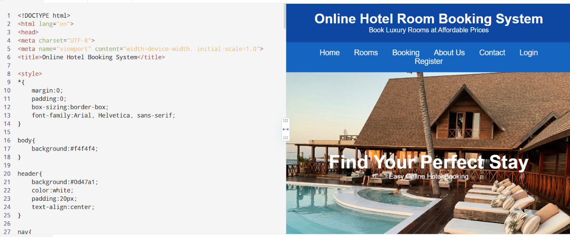

3. The online bus ticket booking system enables users to search for buses by route, date, and time,
and view available seats. Users can create an account, log in, and manage their bookings
through a personal dashboard. The booking process includes selecting seats, filling out
passenger details, and making secure payments via an integrated payment gateway. Admins
can manage bus schedules, seat availability, and user accounts through an admin panel. Users

receive booking confirmation emails and can view their booking history. The website is mobile-
responsive, ensuring easy access on all devices.
Password.
Registration:
This website provides some facilities users can be Registered in this website. user can use thisfacility
so user can make a registration
.
Book the Ticket:
In this module, the admin can add a new bus category using this module. Bus Category contains
like Volvo, Slipper coach, coach etc.
Update Bus Information:
In this module, the admin can add or Update Bus using this module. It contains information
about the Bus type, photo, description, Location of the tour, Available Seats in Bus etc.
Cancel the Booking Ticket:
In this Module, the User can cancel the booking Ticket.
Comments:
In this Module, Users can Post Comments on a particular Bus.
Report Generation:
This module is used to generate a report.

Admin
In this system, the admin can maintain all the Bus information and maintain Bus category,
comments etc.
In this system, the admin can maintain the registered users, manage news, and the admin cangenerate
reports and manage the whole system.
Login:
Login Module includes various utilities like User Authentication, Change Password and Forgot
<!DOCTYPE html>
<html lang="en">
<head>
<meta charset="UTF-8">
<meta name="viewport" content="width=device-width, initial-scale=1.0">
<title>Online Bus Ticket Booking System</title>

<style>
*{
margin:0;
padding:0;
box-sizing:border-box;
font-family:Arial, Helvetica, sans-serif;
}

body{
background:#f4f4f4;
}

header{
background:#0066cc;
color:white;
text-align:center;
padding:20px;
}

nav{
background:#004d99;
padding:15px;
text-align:center;
}

nav a{
color:white;
text-decoration:none;
margin:15px;
font-size:18px;
}

nav a:hover{
color:yellow;
}

.hero{
background:#0099ff;
color:white;
text-align:center;
padding:60px 20px;
}

.search{
background:white;
width:90%;
max-width:1000px;
margin:20px auto;
padding:20px;
border-radius:8px;
box-shadow:0 0 10px gray;
}

.search form{
display:grid;
grid-template-columns:repeat(auto-fit,minmax(180px,1fr));
gap:15px;
}

input,select{
padding:10px;
font-size:16px;
}

button{
background:#0066cc;
color:white;
border:none;
padding:12px;
cursor:pointer;
}

button:hover{
background:#004d99;
}

.section{
padding:40px;
}

.cards{
display:flex;
flex-wrap:wrap;
justify-content:center;
gap:20px;
}

.card{
background:white;
width:280px;
padding:20px;
border-radius:10px;
box-shadow:0 0 8px gray;
}

.card h3{
color:#0066cc;
margin-bottom:10px;
}

footer{
background:#004d99;
color:white;
text-align:center;
padding:20px;
margin-top:30px;
}
</style>

</head>
<body>

<header>
<h1>Online Bus Ticket Booking System</h1>
<p>Book Your Journey Anytime, Anywhere</p>
</header>

<nav>
<a href="#">Home</a>
<a href="#">Search Bus</a>
<a href="#">Book Ticket</a>
<a href="#">Booking History</a>
<a href="#">Login</a>
<a href="#">Register</a>
<a href="#">Contact</a>
</nav>

<section class="hero">
<h1>Find & Book Your Bus Tickets</h1>
<p>Easy • Secure • Fast Booking</p>
</section>

<div class="search">

<h2>Search Bus</h2>
<br>

<form>

<input type="text" placeholder="From">

<input type="text" placeholder="To">

<input type="date">

<select>
<option>Select Time</option>
<option>Morning</option>
<option>Afternoon</option>
<option>Evening</option>
<option>Night</option>
</select>

<button type="submit">Search Bus</button>

</form>

</div>

<section class="section">

<h2 align="center">Available Bus Categories</h2>
<br>

<div class="cards">

<div class="card">
<h3>Volvo Bus</h3>
<p>Luxury AC Bus with Pushback Seats</p>
<p>Available Seats : 30</p>
<button>Book Now</button>
</div>

<div class="card">
<h3>Sleeper Coach</h3>
<p>Comfortable Sleeper Berths</p>
<p>Available Seats : 18</p>
<button>Book Now</button>
</div>

<div class="card">
<h3>AC Coach</h3>
<p>Air Conditioned Coach</p>
<p>Available Seats : 25</p>
<button>Book Now</button>
</div>

<div class="card">
<h3>Non-AC Coach</h3>
<p>Economy Travel Option</p>
<p>Available Seats : 35</p>
<button>Book Now</button>
</div>

</div>

</section>

<section class="section">

<h2>User Services</h2>

<ul>
<li>✔ User Registration</li>
<li>✔ User Login</li>
<li>✔ Search Buses</li>
<li>✔ Book Tickets</li>
<li>✔ Cancel Tickets</li>
<li>✔ View Booking History</li>
<li>✔ View Seat Availability</li>
<li>✔ Secure Online Payment</li>
</ul>

</section>

<section class="section">

<h2>Administrator Services</h2>

<ul>
<li>✔ Admin Login</li>
<li>✔ Manage Bus Categories</li>
<li>✔ Add / Update Bus Information</li>
<li>✔ Manage Users</li>
<li>✔ Manage Seat Availability</li>
<li>✔ Generate Reports</li>
<li>✔ Manage News</li>
<li>✔ Manage Comments</li>
</ul>

</section>

<section class="section">

<h2>Customer Comments</h2>

<textarea rows="5" cols="70"
placeholder="Write your feedback here..."></textarea>

<br><br>

<button>Post Comment</button>

</section>

<section class="section">

<h2>Contact Us</h2>

<p>Email : support@busticket.com</p>

<p>Phone : +1 9876543210</p>

<p>Address : Bus Booking Center, Main City</p>

</section>

<footer>

<p>© 2026 Online Bus Ticket Booking System | All Rights Reserved</p>

</footer>

</body>
</html>
OUT PUT:
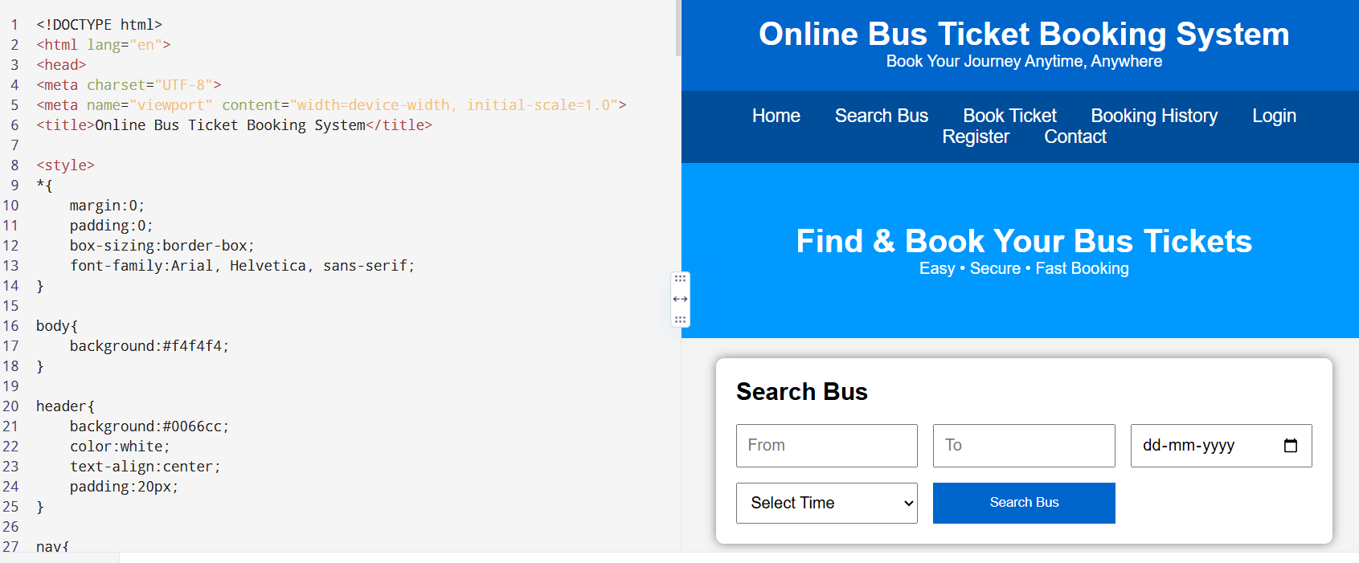

4. The online train reservation system allows users to search for trains by route, date, and time,
and view available seats and classes. Users can register, log in, and manage their reservations
through a personal dashboard. The booking process involves selecting seats, entering passenger
details, and making secure payments via an integrated payment gateway. Admins can manage
train schedules, seat availability, and user accounts through a comprehensive admin panel.
Users receive booking confirmation emails and can view their booking history and print tickets
from their dashboard. The website features real-time seat availability updates and is fully
responsive for seamless use on all devices.
The Reservation system should contain the following features:
1. If a passenger wants to reserve ticket(s), firstly, he/she has to log in to the Railway
system with valid credentials. Then, the passenger has to provide his/her details with
the date of the journey, names of the passengers and their details, origin station
details, destination station details, and the class type of the required ticket(s).

2. The Railway Reservation System will provide the available Train-list, and Seat-
availability, via-details.

3. To book a ticket passengers can pay through online/offline mode. After successful
payment of the ticket fare the System will generate the ticket and PNR no. will be
given to the passenger. The System also keeps the payment details and sends them
to the system Admin.
4. The Passenger can check PNR status (confirmed, RAC, waiting list) by entering the
PNR no. into the Reservation system.
5. The Reservation system should store all train details, fare details (by zone, class,
and date wise), PNR no, date of trains, etc. This maintenance should be controlled
by the Admin.
6. The System also has refund rules which have a date of reservation, ticket fare, and
refundable percentage. The passenger can simply cancel the ticket(s) by entering
the PNR no and a cancel ticket request. After cancellation, the admin will pass the
refundable amount to the System and the System will give the refundable amount
to the passenger.
<!DOCTYPE html>
<html lang="en">
<head>
<meta charset="UTF-8">
<meta name="viewport" content="width=device-width, initial-scale=1.0">
<title>Online Train Reservation System</title>

<style>
*{
margin:0;
padding:0;
box-sizing:border-box;
font-family:Arial, sans-serif;
}

body{
background:#f4f4f4;
}

header{
background:#00695c;
color:white;
text-align:center;
padding:20px;
}

nav{
background:#004d40;
padding:15px;
text-align:center;
}

nav a{
color:white;
text-decoration:none;
margin:15px;
font-size:18px;
}

nav a:hover{
color:yellow;
}

.hero{
background:#26a69a;
color:white;
text-align:center;
padding:60px 20px;
}

.container{
width:90%;
max-width:1100px;
margin:auto;
}

.search-box{
background:white;
padding:20px;
margin-top:20px;
border-radius:8px;
box-shadow:0 0 10px gray;
}

form{
display:grid;
grid-template-columns:repeat(auto-fit,minmax(180px,1fr));
gap:15px;
}

input,select{
padding:10px;
font-size:16px;
}

button{
background:#00695c;
color:white;
border:none;
padding:12px;
cursor:pointer;
}

button:hover{
background:#004d40;
}

.section{
margin-top:30px;
background:white;
padding:20px;
border-radius:8px;
box-shadow:0 0 10px #ccc;
}

table{
width:100%;
border-collapse:collapse;
margin-top:15px;
}

table,th,td{
border:1px solid #999;
}

th,td{
padding:10px;
text-align:center;
}

th{
background:#00695c;
color:white;
}

footer{
background:#004d40;
color:white;
text-align:center;
padding:20px;
margin-top:30px;
}
</style>

</head>
<body>

<header>
<h1>Online Train Reservation System</h1>
<p>Book Your Train Tickets Easily</p>
</header>

<nav>
<a href="#">Home</a>
<a href="#">Search Trains</a>
<a href="#">PNR Status</a>
<a href="#">Booking History</a>
<a href="#">Login</a>
<a href="#">Register</a>
<a href="#">Contact</a>
</nav>

<section class="hero">
<h1>Search & Reserve Train Tickets</h1>
<p>Fast • Secure • Easy Booking</p>
</section>

<div class="container">

<div class="search-box">

<h2>Train Search</h2>
<br>

<form>

<input type="text" placeholder="From Station">

<input type="text" placeholder="To Station">

<input type="date">

<select>
<option>Select Class</option>
<option>Sleeper (SL)</option>
<option>3A</option>
<option>2A</option>
<option>1A</option>
<option>Chair Car (CC)</option>
</select>

<button type="submit">Search Trains</button>

</form>

</div>

<div class="section">

<h2>Available Trains</h2>

<table>

<tr>
<th>Train No</th>
<th>Train Name</th>
<th>Departure</th>
<th>Arrival</th>
<th>Seats</th>
<th>Action</th>
</tr>

<tr>
<td>12627</td>
<td>Karnataka Express</td>
<td>08:00</td>
<td>18:30</td>
<td>Available</td>
<td><button>Book</button></td>
</tr>

<tr>
<td>12723</td>
<td>Telangana Express</td>
<td>09:30</td>
<td>20:15</td>
<td>Available</td>
<td><button>Book</button></td>
</tr>

<tr>
<td>12650</td>
<td>Sampark Kranti</td>
<td>11:00</td>
<td>22:00</td>
<td>RAC</td>
<td><button>Book</button></td>
</tr>

</table>

</div>

<div class="section">

<h2>Check PNR Status</h2>

<br>

<input type="text" placeholder="Enter PNR Number">

<button>Check Status</button>

</div>

<div class="section">

<h2>Passenger Services</h2>

<ul>
<li>User Registration & Login</li>
<li>Train Search</li>
<li>Seat Availability</li>
<li>Book Tickets</li>
<li>Online / Offline Payment</li>
<li>Booking History</li>
<li>Print Ticket</li>
<li>Cancel Ticket</li>
<li>Refund Status</li>
<li>PNR Status Check</li>
</ul>

</div>

<div class="section">

<h2>Administrator Services</h2>

<ul>
<li>Manage Train Details</li>
<li>Manage Routes</li>
<li>Manage Seat Availability</li>
<li>Manage Users</li>
<li>Update Fare Details</li>
<li>Manage Refund Rules</li>
<li>Generate Reports</li>
<li>View Payment Details</li>
</ul>

</div>

<div class="section">

<h2>Contact Us</h2>

<p>Email: support@trainreservation.com</p>
<p>Phone: +1 9876543210</p>
<p>Address: Railway Reservation Office</p>

</div>

</div>

<footer>

<p>© 2026 Online Train Reservation System | All Rights Reserved</p>

</footer>

</body>
</html>
OUTPUT:
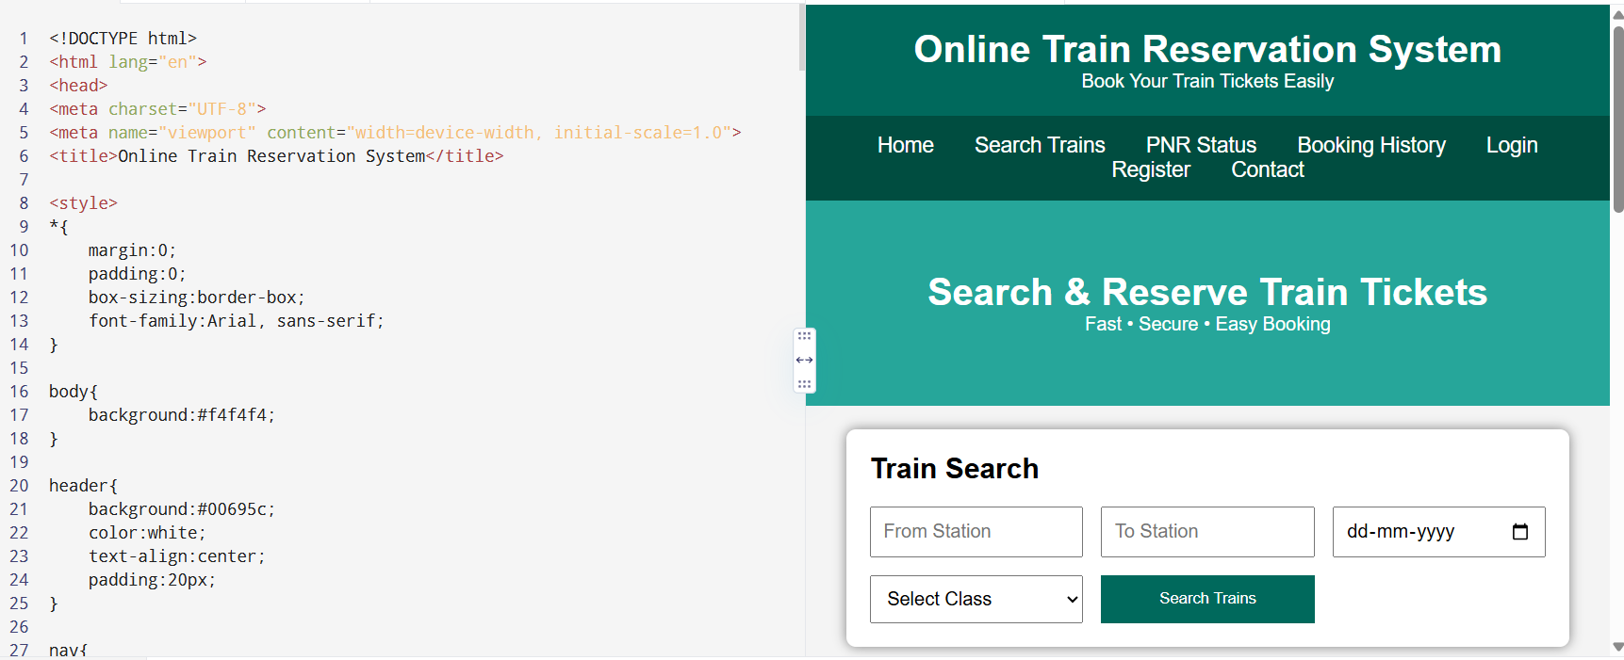

5. The online flight reservation system enables users to search for flights by
destination, date, and class, displaying available options with real-time seat availability.
Users can register, log in, and manage their reservations via a personal dashboard. The
booking process includes selecting flights, choosing seats, entering passenger details, and
making secure payments through an integrated payment gateway. Admins can manage
flight schedules, seat inventory, and user accounts using an advanced admin panel. Users
receive booking confirmation emails with e-tickets and can view their booking history and
travel itineraries. The website is fully responsive, ensuring an optimal experience on all
devices.The airline reservation system is a web-based system that helps in consolidating
flight data - flight schedules, seat availability, flight fares and reservations from all
airlines with the help of global distribution systems and provides real-time inventory and
rates for customers and travel agents to book flight tickets online.
• Administrator User Login Page
• Forgot Password Page
• Search Flight Page
• Book Ticket Page
• Ticket Payment Page
• My Ticket Page
• Cancel Ticket Page
• Customer Feedback
• Admin Report
• Search Flight Page
• View Booking Status Page
• Print Ticket Page
<!DOCTYPE html>
<html lang="en">
<head>
<meta charset="UTF-8">
<meta name="viewport" content="width=device-width, initial-scale=1.0">
<title>Online Flight Reservation System</title>

<style>
*{
margin:0;
padding:0;
box-sizing:border-box;
font-family:Arial, sans-serif;
}

body{
background:#f5f5f5;
}

header{
background:#0b5394;
color:white;
text-align:center;
padding:20px;
}

nav{
background:#073763;
padding:15px;
text-align:center;
}

nav a{
color:white;
text-decoration:none;
margin:15px;
font-size:18px;
}

nav a:hover{
color:yellow;
}

.hero{
background:#4a90e2;
color:white;
text-align:center;
padding:60px;
}

.container{
width:90%;
max-width:1100px;
margin:auto;
}

.search{
background:white;
margin-top:20px;
padding:20px;
border-radius:10px;
box-shadow:0 0 10px #bbb;
}

form{
display:grid;
grid-template-columns:repeat(auto-fit,minmax(180px,1fr));
gap:15px;
}

input,select{
padding:10px;
font-size:16px;
}

button{
background:#0b5394;
color:white;
border:none;
padding:12px;
cursor:pointer;
}

button:hover{
background:#073763;
}

.section{
background:white;
margin-top:25px;
padding:20px;
border-radius:10px;
box-shadow:0 0 10px #ccc;
}

table{
width:100%;
border-collapse:collapse;
margin-top:15px;
}

table,th,td{
border:1px solid gray;
}

th{
background:#0b5394;
color:white;
}

th,td{
padding:10px;
text-align:center;
}

footer{
background:#073763;
color:white;
text-align:center;
padding:20px;
margin-top:30px;
}
</style>

</head>

<body>

<header>
<h1>Online Flight Reservation System</h1>
<p>Book Domestic & International Flights</p>
</header>

<nav>
<a href="#">Home</a>
<a href="#">Search Flights</a>
<a href="#">Book Ticket</a>
<a href="#">My Ticket</a>
<a href="#">Booking Status</a>
<a href="#">Login</a>
<a href="#">Register</a>
<a href="#">Contact</a>
</nav>

<section class="hero">
<h1>Fly Safely, Fly Comfortably</h1>
<p>Search • Book • Travel</p>
</section>

<div class="container">

<div class="search">

<h2>Search Flight</h2>
<br>

<form>

<input type="text" placeholder="From">

<input type="text" placeholder="To">

<input type="date">

<select>
<option>Economy</option>
<option>Premium Economy</option>
<option>Business</option>
<option>First Class</option>
</select>

<button>Search Flight</button>

</form>

</div>

<div class="section">

<h2>Available Flights</h2>

<table>

<tr>
<th>Flight No</th>
<th>Airline</th>
<th>Departure</th>
<th>Arrival</th>
<th>Seats</th>
<th>Fare</th>
<th>Action</th>
</tr>

<tr>
<td>AI101</td>
<td>Air India</td>
<td>08:00 AM</td>
<td>10:15 AM</td>
<td>25</td>
<td>$180</td>
<td><button>Book</button></td>
</tr>

<tr>
<td>6E305</td>
<td>IndiGo</td>
<td>11:30 AM</td>
<td>01:45 PM</td>
<td>18</td>
<td>$150</td>
<td><button>Book</button></td>
</tr>

<tr>
<td>SG220</td>
<td>SpiceJet</td>
<td>04:00 PM</td>
<td>06:20 PM</td>
<td>10</td>
<td>$170</td>
<td><button>Book</button></td>
</tr>

</table>

</div>

<div class="section">

<h2>Passenger Services</h2>

<ul>
<li>✔ User Registration</li>
<li>✔ User Login</li>
<li>✔ Search Flights</li>
<li>✔ Book Tickets</li>
<li>✔ Secure Online Payment</li>
<li>✔ View Booking Status</li>
<li>✔ Print E-Ticket</li>
<li>✔ Cancel Ticket</li>
<li>✔ Booking History</li>
<li>✔ Customer Feedback</li>
</ul>

</div>

<div class="section">

<h2>Administrator Services</h2>

<ul>
<li>✔ Admin Login</li>
<li>✔ Forgot Password</li>
<li>✔ Manage Flights</li>
<li>✔ Manage Seat Availability</li>
<li>✔ Manage Flight Schedules</li>
<li>✔ Manage Users</li>
<li>✔ Generate Reports</li>
<li>✔ View Ticket Payments</li>
</ul>

</div>

<div class="section">

<h2>Customer Feedback</h2>

<textarea rows="5" cols="70" placeholder="Write your feedback here..."></textarea>

<br><br>

<button>Submit Feedback</button>

</div>

<div class="section">

<h2>Contact Us</h2>

<p>Email: support@flightbooking.com</p>
<p>Phone: +1 9876543210</p>
<p>Address: International Airport, Main City</p>

</div>

</div>

<footer>

<p>© 2026 Online Flight Reservation System | All Rights Reserved</p>

</footer>

</body>
</html>
OUTPUT:
